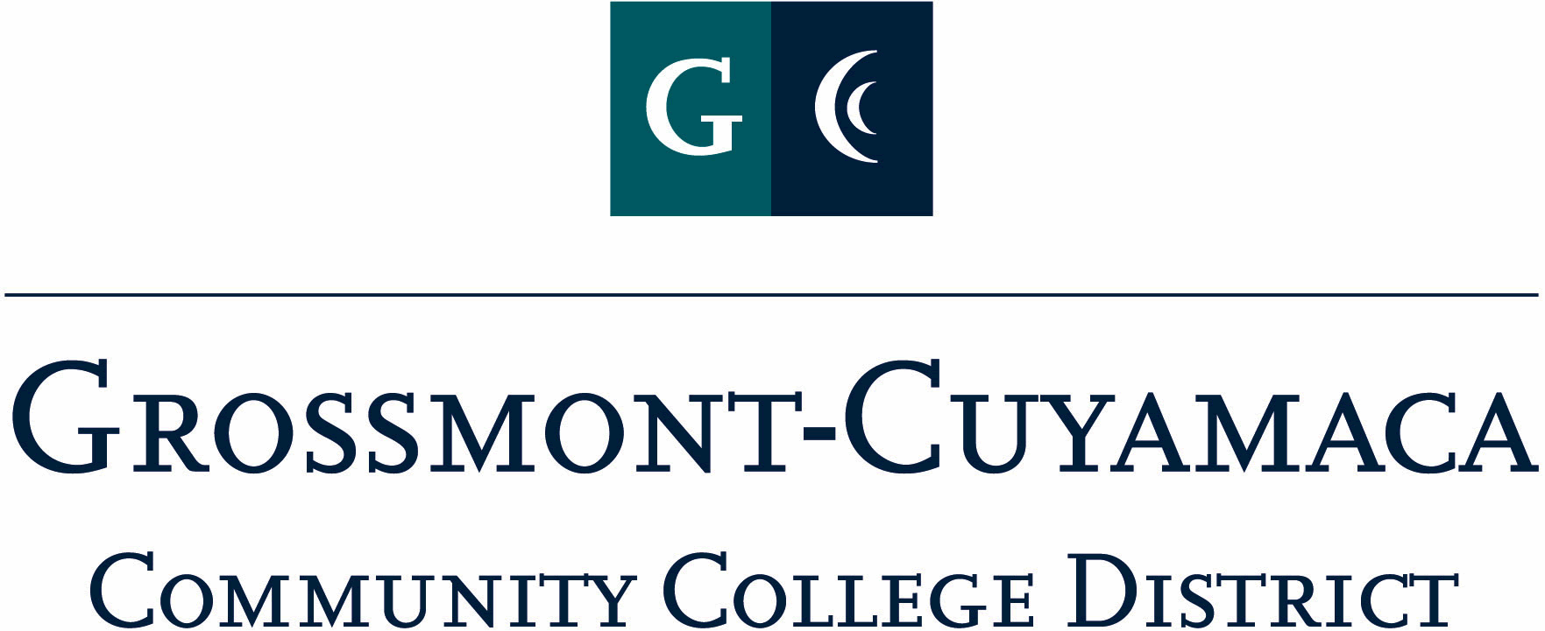
D R A F T
CLASSIFIED SENATE
EXECUTIVE BOARD MEETING
August 2, 2011– Meeting Minutes

Members Present: Wendy Corbin, Maria Briney, Debi Miller, Avelina Mitchell, Patricia Bailey, Ken Grimes, Connie Sterling, Yvette Macy, Jennine Boschock, Nicole Boyer, Robert Mountain, Joe Balestreri, Glenn Macy, Rocky Rose
Members Absent: Kari Crawford, Melissa Chandler, Jean Wallace, Pat Murray, Mary Eden, Patty Sparks
Members Excused: Angela Johnson, Pamela Wright

1. Welcome and Call to Order: The meeting was called to order at 12:06p.

2. Approval of Minutes from 7/12/11: The minutes from 7/12/11 meeting were approved as amended. M/S/A Mountain/Macy. Motion passed.

3. Communication

VP Reports

President’s Report: Wendy Corbin asked the group to send any ideas for the agenda template to her. Wendy Corbin reported on the following items:
District Executive Council (DEC) July meeting: (1) In preparation for Accreditation a task force is being formed called the District Coordinating Task Force in an effort to improve process, communication, best practice and enhance resources and site efforts. (2) The District Services Reorg will not be moving forward with an Executive Vice Chancellor for Business & Human Resources instead an Interim Associate Vic Chancellor has been hired as a consultant and started yesterday and will be in the office 3 times a week. (3) The 501 Docket continues to be a concern at this meeting because it is in flux until posted and then changes again at the Governing Board meeting. Debi Miller commented that Wendy Corbin should keep addressing the untimeliness of these Governing Board docket items for submittal. Robert Mountain asked that the acronyms be spelled out in the Agenda for those who are not familiar with them and asked Wendy to explain their charge.

District Strategic Planning & Budget Council (DSPB&C): District, Grossmont, and Cuyamaca are in the process of evaluating last year’s strategic plan and a presentation will take place at the pre-Board meeting in August. State Accreditation Training will take place on 10/21 and will include Grossmont & Cuyamaca as well as 3 other colleges. DSPB&C has budgted for a total district-wide FTES of 17,142 which was on the CA budget. These additional FTES translate to 100 extra sessions being offered to our students district-wide.

Staff Development: Wendy Corbin met with Chancellor and she indicated the classified senate role in professional development is to simply make sure we are plugged into the needs for the classified. It is apparent the district-wide effort is not consistent. As soon as the Associate Vice Chancellor comes up to speed we will make it a priority to work with Tim Corcoran on this matter.

Classified Leadership Meeting: These meetings will now be teleconferenced and any Board member is invited to attend, just contact Wendy for the dates. The mentoring project was discussed with the Chancellor and she expressed caution, mostly doesn’t think classified are qualified. Angela Johnson was a bit discouraged. Wendy’s thought was to back up a bit and gather more ideas together and possibly incorporate efforts that are already taking place on the campuses. Further discussion on this item will be brought to the Retreat. She added that members of classified are in the initial stages of orchestrating changes to AB1725 by adding clarifying language to define classified staff and why important. Mother Goose Parade update is that a fire truck is available for use by both colleges, and the Chancellor would like to be on the truck.

Governing Board Report. Wendy stated that this is the Classified Senate report to the Governing Board monthly and are all important parts of this group, if there is anything you would like her to share with the Board, please send to her.

Classified Senate Retreat: the Off Campus Activity Form needs to be filled out and submitted to your supervisor for approval. This is release time for everyone who attends. If you have any calendar requests please forward to Wendy or Debi.

She has tasked the mini boards to brain storm on (1) review projects; (2) come up with feedback and input from site level to establish future goal setting.

Excused Absence Protocol: Wendy asked the group that if you can’t make it to the meeting she understands everyone is busy, please notify either Wendy or Debi via e-mail. We want everyone to be engaged in the process. Yvette Macy inquired about the excused rule in the Constitution & Bylaws. She added that it is important to be able to count on folks and we are looked at as a team. It is important that the group pay attention to that protocol. Debi Miller added that she tracks the absences and when there are 3 absences in a row without an excuse she will forward that information to Wendy Corbin.

District: Yvette Macy reported on the following:

District Services Leadership Council (DSL): At the Classified Leadership meeting, she brought a concern to Wendy about the DSL Council do not seem like a council to her. The Council does not weigh in on anything in that meeting. She reported about the tasks of this Council and is concerned that it is just a reporting council and no decisions are made. There was a discussion among the group on the difference between a council and a committee and aren’t council there to recommend. It was shared that it would depend on the charge that is established for the council.

Site Committee: The district mini board got together over lunch to share goals, challenges and aspirations. She wanted to thank everyone for attending and joining her and look forward to accomplishing the discussion about more professional development week activities, better work environment to work more with students.

Grossmont: Joe Balestreri reported on the following:

Grossmont Planning & Budget Council: He is not currently a member of this committee, but is a member of the Leadership Council. The Recorder will make that change in the agenda template. The Leadership Council mostly trying to make decision on using the website for complaint form before going straight to the district. It would offer a place to go to voice their complaints. State mandated concern. Nothing finalized. Dr. Cooke asked about seating reps for the DEI for our site she believes it is really hard for her VPs to sit on a 3-chair committee – scheduling was challenging for 3. Wendy Corbin suggested he go back and talk to his comrades.

Cuyamaca: Avelina Mitchell reported on the following:

Institutional Effectiveness & Resource Council (IERC): will hold its 1st meeting on 8/23.
She did meet with the President about awards and going over that. She suggested a possible future fundraiser be delivering tamales at Christmas time and similar to the Dudley bread fundraiser. There is a place in Chula Vista to see if they would work with us on something like this. Would they handle all the food? She will research and bring back to the group next month.

Treasurer Report: Maria Briney reported that the Classified Senate Trust balance is $2,487.87 and the Classified Staff Appreciation Day (Staff Development) is at $5,000. Debi Miller asked her to count on the carry over amount and bring back to the next meeting. Wendy Corbin added that the Trust and the Staff Development fund account will be discussed at the Retreat.

4. Continuing Business

Beach Picnic: E-mail about the Flash Mob get together went out. This is a way to get away from work. If available, tell a friend. Be down there all day to make it fun.

50/50 Drawing: If we try to do a 50/50 drawing to donate to something. Check with Pat Murray. Wendy will check to see if there are any legal issues concerning this and then solicit a vote to conduct the drawing at the Beach Picnic.

5. Projects:
Motion to table Agenda Items 5 & 6 and bring back to the next meeting: M/S/A Macy/Boyer . Motion passed.

Fundraising: Tabled to 9/13 meeting
Assist-A-Student: Tabled to 9/13 meeting
Mother Goose Parade: Tabled to 9/13 meeting

Wendy asked the secretary to move these items to the Continuing Business on the next agenda.

6. Governance:

Site Committee List: Tabled to 9/13 meeting
Posting Committee Reports to Website: Table to 9/13 meeting

7. New Business:

Website: Wendy Corbin would like it to be much more dynamic. She asked for the board to work together including reporting from committees and read like a newspaper within the next 2 years. Rocky Rose expressed his concern with having too many people having access to editing the website. Speaking from past history, it ended up being a concern. There really should be a designated person to facilitate website updates.

The meeting adjourned at 12:58p.

